NSA AND SA

* **NSA (Non-Standalone) Architecture:**
* **Definition:** NSA is an initial deployment mode for 5G networks that relies on existing 4G LTE infrastructure. In NSA mode, 5G New Radio (NR) is integrated with 4G LTE, which serves as the anchor for control and signaling.
* **Components:**
  + **5G NR:** Provides high-speed data services and improved performance for mobile users.
  + **4G LTE:** Manages control signaling, mobility, and other core functions.
* **Functionality:**
  + **Dual Connectivity:** Devices connect to both 4G LTE and 5G NR simultaneously. The 5G NR handles high-speed data, while the 4G LTE network handles signaling and control functions.
  + **Network Dependency:** NSA requires an existing 4G LTE network as its backbone, which limits the full potential of 5G features.
  + **Benefits:** Faster deployment and utilization of existing infrastructure. Lower initial investment compared to building a standalone 5G network from scratch.
* **Use Case:** Often used during the early stages of 5G deployment to provide 5G services quickly while leveraging existing 4G LTE networks.
* **SA (Standalone) Architecture:**
* **Definition:** SA is a fully native 5G deployment mode that does not rely on 4G LTE infrastructure. It uses a dedicated 5G core network and 5G NR for both control and data.
* **Components:**
  + **5G NR:** Provides both data and control functions, fully utilizing the capabilities of the 5G radio access network.
  + **5G Core Network:** Handles all control, signaling, and data functions without relying on 4G LTE.
* **Functionality:**
  + **End-to-End 5G:** Both the radio access network (5G NR) and the core network are built to support 5G features, allowing for the full range of 5G capabilities.
  + **Advanced Features:** Supports advanced 5G features like network slicing, ultra-low latency, and high reliability.
  + **Benefits:** Greater efficiency, lower latency, and the ability to fully utilize 5G's advanced features.
* **Use Case:** Ideal for operators looking to maximize the benefits of 5G, including ultra-fast speeds, lower latency, and new applications such as IoT and advanced automation.
* **Diagram:**

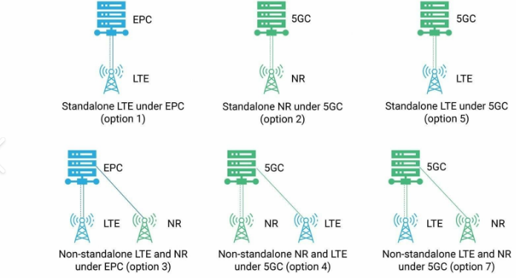

**NSA**: Provides a quicker, cost-effective way to deploy 5G by integrating with existing 4G infrastructure. Ideal for early adoption and initial 5G rollouts.

**SA**: Represents a complete 5G implementation, offering the full range of 5G features and performance. Suitable for advanced applications and future-proofing the network.

**Differences:NSA and SA**

